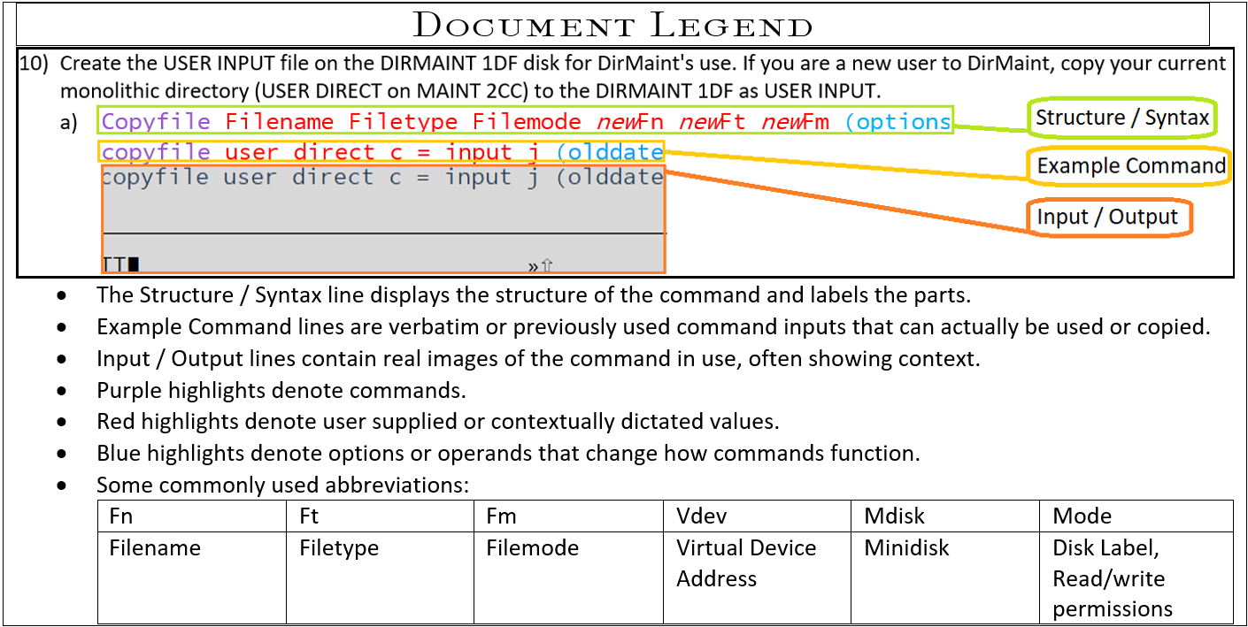

Task Overview:

1. Establish access to relevant Minidisks for file editing.
2. Edit relevant files to provide connectivity parameters.
3. Relog TCPIP user to apply changes to production.

Detailed Steps:

1. Obtain access to MDISKs to edit relevant files; System Config on PMAINT CF0 and SYSTEM DTCPARMS + TCPIP PROFILE on TCPMAINT 198.
   1. VMLINK ownerid vdev (options  
      Vmlink PMAINT CF0 (Write  
      
   2. VMLINK ownerid vdev (options  
      Vmlink TCPMAINT 198 (Write  
      
2. Edit the System Configuration file on PMAINT CF0 to include the virtual switch information and establish the type of connection.   
   Xedit filename filetype filemode  
   Xedit System Config z  
   
   1. /Searchterm  
      /System_Alias  
      
      1. Navigate through xedit with UP/Down and # of lines. Alternatively use F7 and F8.

UP #  
UP 10

* + 1. Add lines as needed by typing A# where A stands for add and # will be the number of lines to add. This can be submit from the command line as shown above with / or in the prefix column number area.  
       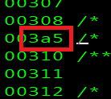
    2. Be sure to use the FILE command to save changes.
  1. In the example below line 309 was added to **system config** to permanently define these Virtual Switches.

00304 /**********************************************************************/

00305 /* ADD VSWITCH */

00306 /**********************************************************************/

00307 DEFINE VSWITCH VSW1 RDEV 00CD

00308 DEFINE VSWITCH VSW2 RDEV 0C6D

00309 DEFINE VSWITCH VSW3 RDEV 0C73

00310 VMLAN MACPREFIX 0200A1

* 1. Edit the SYSTEM DTCPARMS located on TCPMAINT 198 if; you’re OSA device addresses are not already listed, the type is not set as a server or the class is not set to stack. This should be generated by TCPIP originally.
     1. Xedit filename filetype filemode  
        Xedit System DTCPARMS X  
        XEDIT SYSTEM DTCPARMS
     2. Example of DTCPARMS file contents:  
        00005 :nick.TCPIP :type.server  
        00006 :class.stack

00007 :attach.00C9-00CB,0C6A-0C6C,0C70-0C72

* 1. Edit the PROFILE TCPIP located on TCPMAINT 198 to contain; the Device statement specifying your OSA device information and, Link statement specifying the connection type and parameters as shown below.
     1. Example of Device and Link statements:

00039 DEVICE OSAC00037 DEVICE OSAC6NROUTER PORTNAME OSAC7

00040 LINK ETH3 QDIOETHERNET OSAC7 MTU 1500 IP VLAN 71

00041 ; (End DEVICE and LINK statements)

* + 1. Further edit the PROFILE TCPIP file to add HOME, GATEWAY, START and, DEFAULTNET statements to establish more connection values.
       1. Example of HOME, GATEWAY, IP, DEFAULTNET, and START statements below:

00035 DEVICE DEV@00C9 OSD 00C9 NONROUTER

00036 LINK ETH0 QDIOETHERNET DEV@00C9 PATHMTU MTU 1500 IP

00037 DEVICE OSAC00035 DEVICE DEV@0NROUTER PORTNAME OSAC6

00038 LINK ETH2 Q00036 LINK ETH0 QD MTU 1500 IP VLAN 72

00039 DEVICE OSAC00037 DEVICE OSAC6NROUTER PORTNAME OSAC7

00040 LINK ETH3 QDIOETHERNET OSAC7 MTU 1500 IP VLAN 71

00041 ; (End DEVICE and LINK statements)

00042 ; ----------------------------------------------------------------------

00043 ; ----------------------------------------------------------------------

00044 HOME

00045 12.1.12.123 255.255.240.0 ETH0

00046 12.123.1.12 255.255.255.0 ETH2

00047 12.123.1.123 255.255.255.0 ETH3

00048 ; (End HOME Address information)

00049 ; ----------------------------------------------------------------------

00050 GATEWAY

00051 ; Network Subnet First Link MTU

00052 ; Address Mask Hop Name Size

00053 ; ------------- --------------- --------------- ---------------- -----

00054 12.123.1.123 255.255.255.0 = ETH2 1500

00055 12.1.12.1 255.255.240.0 = ETH0 1500

00056 12.123.1.254 255.255.255.0 = ETH3 1500

00057 DEFAULTNET 10.4.80.1 ETH0 1500

00058 ; (End GATEWAY Static Routing information)

00059 ; ----------------------------------------------------------------------

00060 START DEV@00C9

00061 START OSAC6

00062 START OSAC7

00063 ; (End START statements)

* 1. Verify that the values listed in multiple fields and statements have matching names and device numbers and are structured in compliance with the statement rules.

1. Verify there are no issues with the System Config changes by linking MAINT 193 to run the CPSYNTAX executable.
   1. VMlink ownerid vdev  
      Vmlink MAINT 193  
      
   2. CPSYNTAX filename filetype filemode  
      CPSYNTAX system config x  
      
2. Force TCPIP offline and log into the HMC to open an Integrated 3270 Console for the system being worked on. From within the terminal submit an XAUTOLOG command to relog the user online as DSC disconnected.
   1. Force User  
      Force TCPIP  
      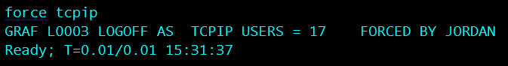
   2. Log onto the HMC hmc.doa.la.gov:  
      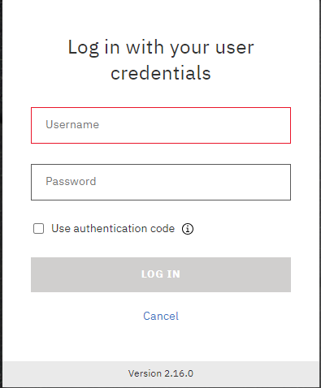
   3. Open your Integrated 3270 Console.  
      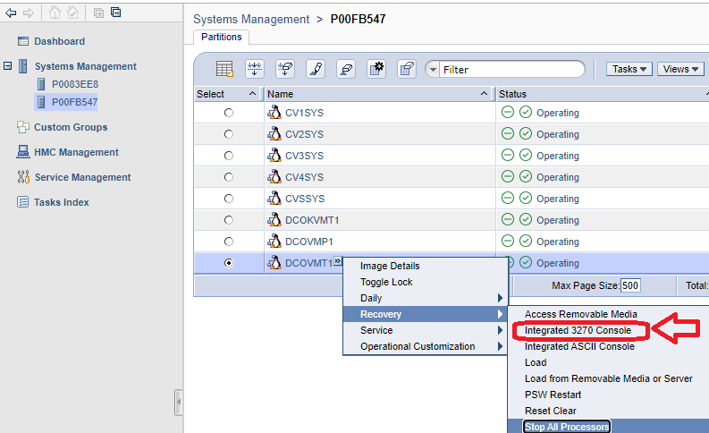
   4. Once logged in submit the XAUTOLOG command for TCPIP to bring it online disconnected again and begin doing work.
      1. Xautolog user iplparm  
         Xautolog tcpip  
         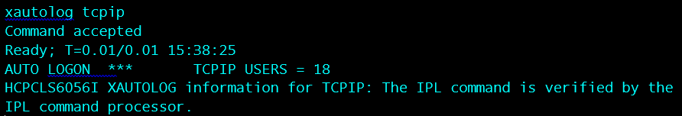
3. Monitor for any errors or unexpected output messages.